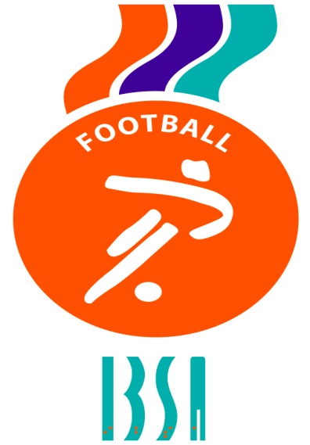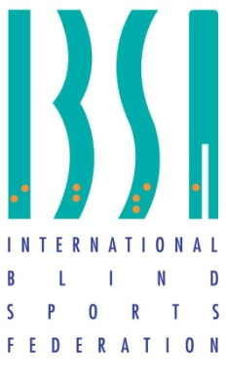

IBSA BLIND FOOTBALL WORLD RANKING – B1

1st January 2021

Ranking Country
1 Argentina
2 Brazil
3 Spain
4 Turkey
5 China
6 Iran
7 England
8 Russia
9 Mexico
10 Morocco
11 Colombia
12 Japan
13 Thailand
14 France
15 Mali
16 Peru
17 South Korea
18 Malaysia
19 Romania
20 Costa Rica
21 Egypt
22 Italy
23 Chile
24 Germany
25 Belgium
26 Georgia
27 Greece
28 India
29 Ivory Coast
30= Cape Verde
30= Nigeria
32 Cameroon
33 Niger
34= Oman
34= Libya
36 Ireland
37 Hungary
38 Guatemala
39 El Salvador
40 Belarus
41 Nicaragua
42 Laos
43 Albania
44 Moldova
45 Poland
46 Vietnam
47 Honduras
48 Czech Republic
49 Austria
50 Switzerland

IBSA Football Committee
January 2021

